**Literature survey**

The main objective of our project is to make advancements in the field of healthcare and AI more accessible using the widespread of internet even in the most rural parts of the nation. Before starting the project, many research papers were read to get the idea of the present technology existing and its limitation. As we are making various machine learning based models, the papers we studied are from a broad range of subtopics in the field of machine learning. It includes the diagnosis of atrial fibrillation using ECG signals, classifying disease and generating an area of focus in a chest x-ray image, malaria using blood cell microscopic images and Alzheimer’s detection at an early stage, diabetic retinopathy. We have also created class activation maps[2] for the references of doctors.

Datasets –

1. ECG – MIT-BIH dataset, Stanford ml group arrythmia dataset
2. Pneumonia – Chexpert, NIH chest xray dataset
3. Malaria dataset – Kaggle
4. Alzheimer dataset – Oasis 3/acni

**CNN** - Deep neural networks and Deep Learning are powerful and popular algorithms. And a lot of their success lays in the careful design of the neural network architecture. Subfield of deep learning computer vision has only exploded recently due to the breakthrough moment happened in 2012 when AlexNet won imagenet competition. AlexNet used convolutional neural network based architecture for the first time and there have been the development in this field ever since. In our project for the image data we have used densenet-121 [1].

**Densenet[1]** – It is one of the latest neural networks for visual object recognition. DenseNet, which connects each layer to every other layer in a feed-forward fashion. Whereas traditional convolutional networks with L layers have L connections — one between each layer and its subsequent layer — our network has L(L+1)/ 2 direct connections. For each layer, the feature-maps of all preceding layers are used as inputs, and its own feature-maps are used as inputs into all subsequent layers. DenseNets have several compelling advantages: they alleviate the vanishing-gradient problem, strengthen feature propagation, encourage feature reuse, and substantially reduce the number of parameters. For our applications we have used densenet-121. Here 121 signifies the depth of the cnn architecture.

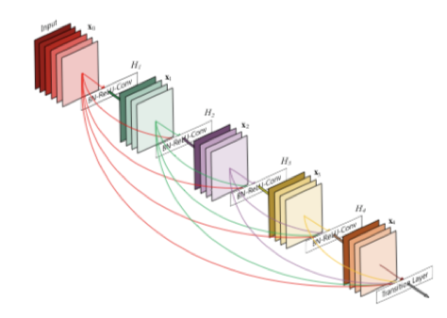

Figure 1. A 5-layer dense block with a growth rate of k = 4. Each layer takes all preceding feature-maps as input.

**Class activation map[2]** - Class activation maps are a simple technique to get the discriminative image regions used by a CNN to identify a specific class in the image. In other words, a class activation map (CAM) lets us see which regions in the image were relevant to this class. The authors of the paper show that this also allows re-using classifiers for getting good localization results, even when training without bounding box coordinates data. This also shows how deep learning networks already have some kind of a built-in attention mechanism. The purpose of using class activation map in our project is for the reference to doctors to show the region of interest.

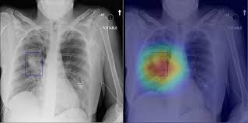

Cardiac arrythmia prediction – Cardiac arrhythmia is a condition where heart beat is irregular. For the prediction. The ecg data is used for prediction. Many previous ECG classiﬁcation algorithms are mainly focused on signal processing technique. Recent approaches are focused on deep learning. [3] uses a deep 1-d CNN network with skip connections, this approach is very computationally expensive and also don’t take the benefits of lstm/rnn for such time series data. [4] uses a unique technique in which instead of applying lstm directly on the ecg signal, they first extracted features using segmentation and wavelet features. They use two models by subdividing the extracted features and applying lstm on these extracted features. They then blend the two models using multi-layer perceptron. This technique gives a great jump in the accuracy over earlier techniques.

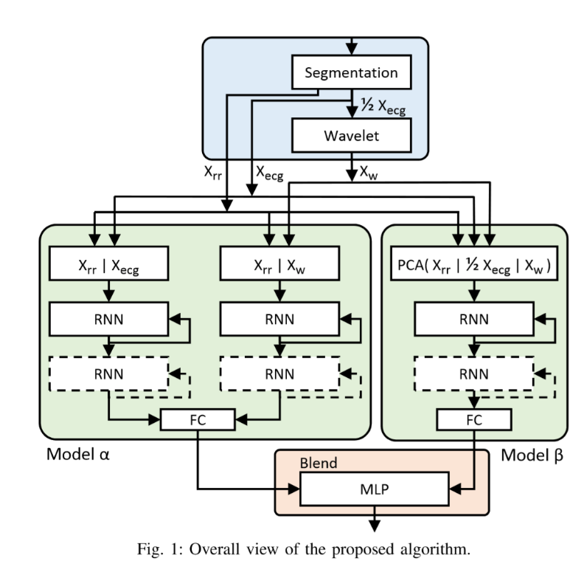

Current developments in deep learning have led to creation of various model for different tasks in bunch of domains. For example, for a time series data, Recurrent neural networks (RNN) are a great development for any data that depends on time. As the features which are extracted from ecg data is time based we tried the rnn based model.

References

Jeremy Irvin, P. R. (2019). CheXpert: A Large Chest Radiograph Dataset with Uncertainty Labels and Expert Comparison. *Computer Vision and Pattern Recognition (cs.CV)*, 10.

# [1] Densely Connected Convolutional Networks, [Gao Huang](https://arxiv.org/search/cs?searchtype=author&query=Huang%2C+G), [Zhuang Liu](https://arxiv.org/search/cs?searchtype=author&query=Liu%2C+Z), [Laurens van der Maaten](https://arxiv.org/search/cs?searchtype=author&query=van+der+Maaten%2C+L), [Kilian Q. Weinberger](https://arxiv.org/search/cs?searchtype=author&query=Weinberger%2C+K+Q).

# [2] Learning Deep Features for Discriminative Localization

[Bolei Zhou](http://people.csail.mit.edu/bzhou/) [Aditya Khosla](http://people.csail.mit.edu/khosla/) [Agata Lapedriza](http://www.cvc.uab.es/~agata/) [Aude Oliva](http://cvcl.mit.edu/aude.htm) [Antonio Torralba](http://web.mit.edu/torralba/www/)  
Massachusetts Institute of Technology

# [3] ECG Heartbeat Classiﬁcation: A Deep Transferable Representation. Mohammad Kachuee, University of California, Los Angeles (UCLA) Los Angeles, USA

[4] LSTM-Based ECG Classiﬁcation for Continuous Monitoring on Personal Wearable Devices Saeed Saadatnejad, Mohammadhosein Oveisi, and Matin Hashemi